**Project Design Phase-II**

**Data Flow Diagram & User Stories**

|  |  |
| --- | --- |
| Date | 27 June 2025 |
| Team ID | LTVIP 2025TMID50734 |
| Project Name | VISUALIZING HOUSING MARKET TRENDS |
| Maximum Marks | 4 Marks |

**Data Flow Diagrams:**

A Data Flow Diagram (DFD) is a traditional visual representation of the information flows within a system. A neat and clear DFD can depict the right amount of the system requirement graphically. It shows how data enters and leaves the system, what changes the information, and where data is stored.

**Example:** [**(Simplified)**](https://developer.ibm.com/patterns/visualize-unstructured-text/)

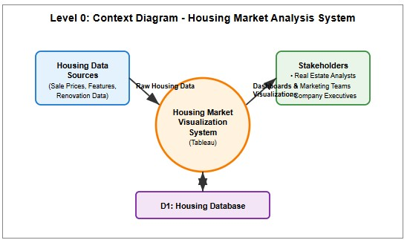

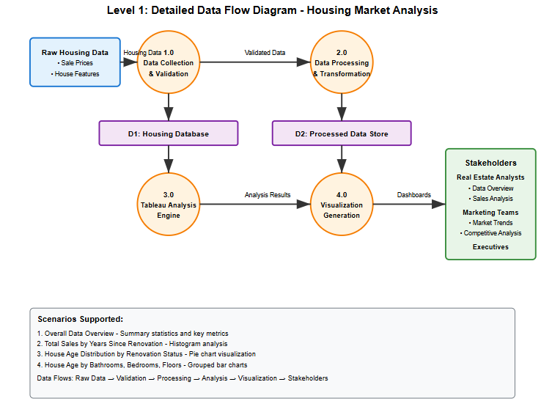

**User Stories:**

|  |  |  |  |  |  |  |
| --- | --- | --- | --- | --- | --- | --- |
| **User Type** | **Functional**  **Requirement (Epic)** | **User Story**  **Number** | **User Story / Task** | **Acceptance criteria** | **Priority** | **Release** |
| Real Estate  Analyst | Data Overview | USN-1 | As a real estate analyst, I want to view the overall housing data summary to understand dataset scale and key metrics | I can view dataset summary with count, average price, and total area | High | Sprint-1 |
| Real Estate Analyst | Sales Analysis | USN-2 | As a real estate analyst, I want to analyze total sales by years since renovation to understand renovation impact on pricing | I can analyze correlation between renovation timing and sales prices | High | Sprint-1 |
| Real Estate  Analyst | Age Distribution | USN-3 | As a real estate analyst, I want to view house age distribution by renovation status to assess inventory characteristics | I can view pie chart showing age groups and renovation status | Medium | Sprint-1 |
| Real Estate  Analyst | Feature Analysis | USN-4 | As a real estate analyst, I want to analyze house age distribution by bathrooms, bedrooms, and floors to identify market patterns | I can analyze house features vs age patterns in grouped bar charts | Medium | Sprint-2 |
| Marketing Team | Market Trends | USN-5 | As a marketing team member, I want to access housing market trend visualizations to inform pricing strategies | I can access visualizations showing market trends for strategic planning | High | Sprint-1 |
| Marketing Team | Competitive Analysis | USN-6 | As a marketing team member, I want to understand buyer preferences for renovated vs non-renovated properties | I can view comparative analysis of renovated vs non-renovated properties | Medium | Sprint-2 |
| Company  Executive | Executive Dashboard | USN-7 | As a company executive, I want to access high-level market insights dashboard to make strategic decisions | I can access executive dashboard with key insights and KPIs | High | Sprint-1 |
| Data  Administrator | System  Maintenance | USN-9 | As a data administrator, I want to monitor data processing and system performance | I can monitor system  performance and data  integrity | Low | Sprint-2 |